SUMMERVILLE CREDIT UNION · CONSOLIDATED MEMBER GUIDE · CSUM-27 of 30
Credit Score & Financial Tools

Module: nFinia Digital Banking > More > Credit Score / Financial Tools
Sources: Summerville Reports Series A (36 docs) + Series B (25 docs) | Features: nFinia Documentation Features Spreadsheet
01 PRODUCT SUMMARY

The Credit Score feature gives members on-demand access to their latest credit score and credit report summary without impacting their credit rating. The score is retrieved via a soft pull from an integrated credit bureau partner. Members must provide consent during their first access; after that, the score is refreshed periodically automatically.
The credit score display includes the member's current score, score range, score rating, key factors affecting the score, and score history trend. FICO Score FAQs are available within the feature to help members understand what their score means and how to improve it.
Financial Tools (where available) provide additional money management capabilities including goals tracking, budget planning, and spending analysis linked to the member's transaction data. These tools help members connect their daily banking activity to longer-term financial goals.

At a Glance

Attribute | Detail
Module | More > Credit Score / Financial Tools
Credit Bureau | Integrated third-party credit bureau (soft pull — no credit impact)
First Access | Consent screen required; thereafter auto-refreshed periodically
Score Display | Current score, rating, key factors, score history
Financial Tools | Goals, budgeting, spending analysis (availability varies)
Related Reports | CSUM-24 (My Insights), CSUM-03 (Account Overview)

02 KEY USE CASES

Use Case | Who Uses It | What They Do | Business Value
Check Credit Score | Members monitoring credit health | Open Credit Score > accept consent > view current score | Free on-demand credit monitoring without a hard inquiry or credit impact
Review Score Factors | Members working on credit improvement | Read the key factors section in Credit Score | Identifies specific factors to address for targeted score improvement
Set Financial Goals | Members planning savings targets | Open Financial Tools > Goals > set a savings goal with target amount | Connects daily banking behaviour to specific financial milestones
Understand FICO | Members new to credit monitoring | Open FICO FAQs from the Credit Score section | Educational resource explaining what the score means and how it is calculated

03 STEP-BY-STEP GUIDE

Navigation: Dashboard > More > 'Credit Score' OR 'Financial Tools'.
Step 1 — Start from Dashboard
The member begins at the Dashboard after logging in. The Dashboard displays all account balances, upcoming payments, quick-action tiles, and the top navigation bar with links to Accounts, Move Money, and More.
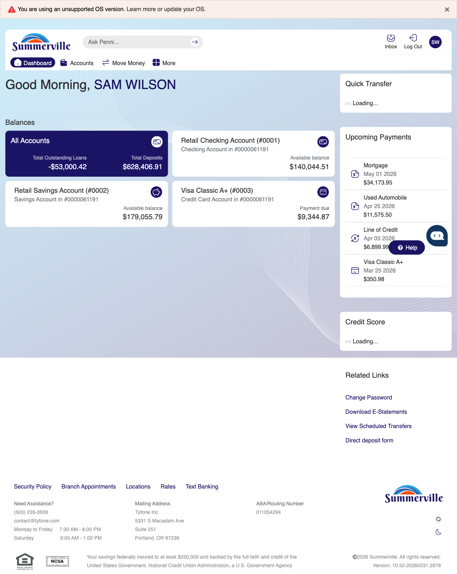
Step 1: Start from Dashboard

Step 2 — Open the More Menu
The member clicks ‘More’ in the top navigation bar. The More options panel expands to show additional features: Check Deposit, User ID and Password, eDocuments, Account Alerts, General Alerts, Password, Forms, One-Time Passcode, Skip A Pay, Do-Not-Disturb, Manage Devices, My Insights, Alert Settings, Recent Activities, and Card Services.
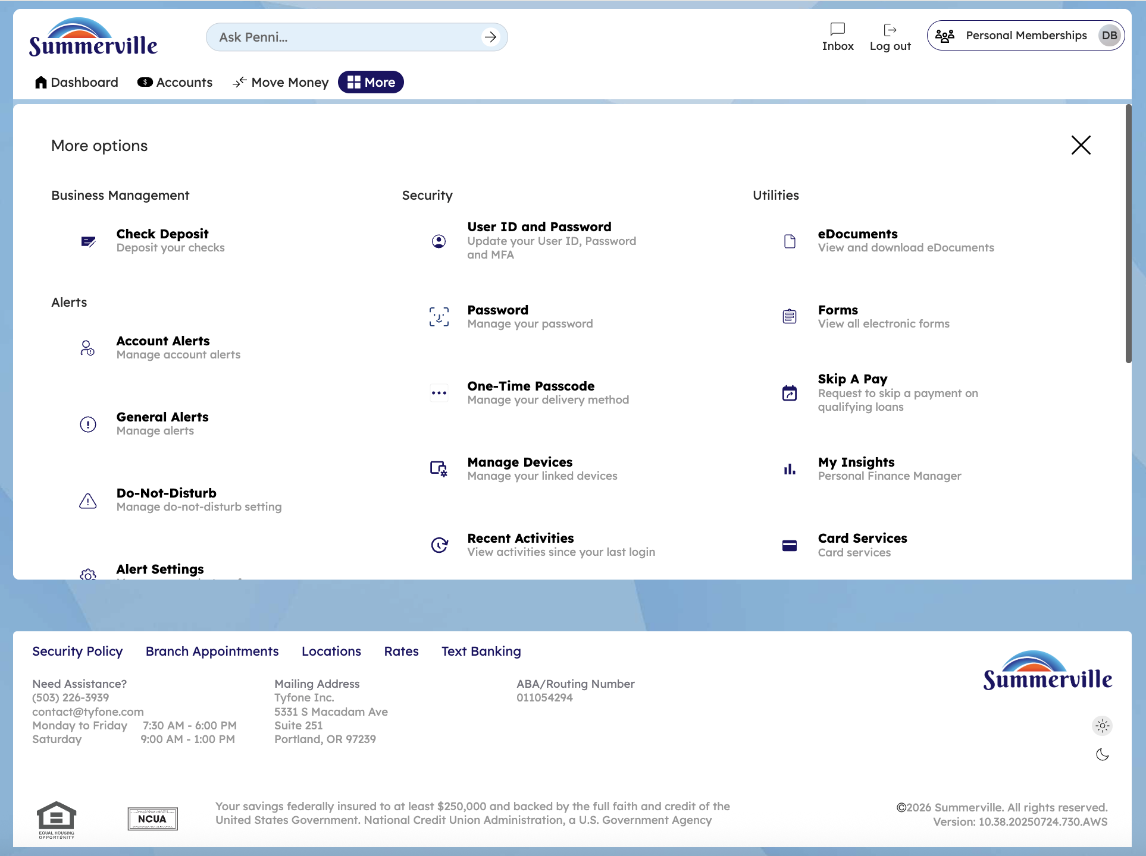
Step 2: More Menu

Step 3 — Navigate from Dashboard to Credit Score
The Credit Score page is displayed with consent information describing the credit score service and a blue action button for the member to access their credit score data.
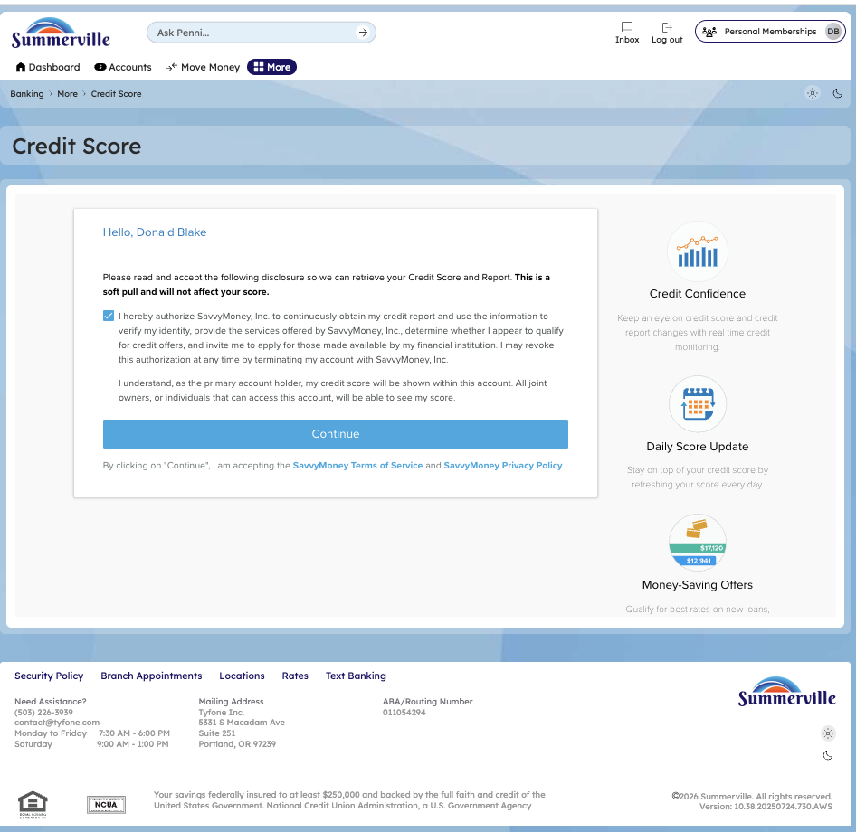
Step 3: Navigate from Dashboard to Credit Score

Step 4 — Score Not Found — Thin Credit File
The Credit Score page shows a message indicating that credit score information is not currently available, with a button to proceed or retry the lookup.
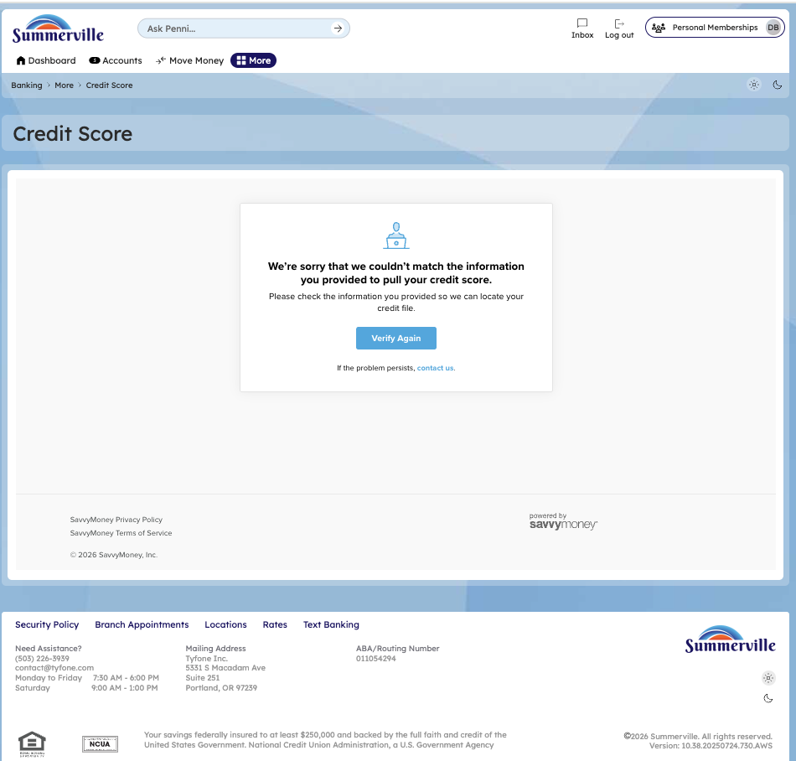
Step 4: Score Not Found — Thin Credit File

Step 5 — Re-Confirm Credit Score Consent
The Credit Score page displays a re-confirmation consent screen with updated terms and information about accessing credit score data.
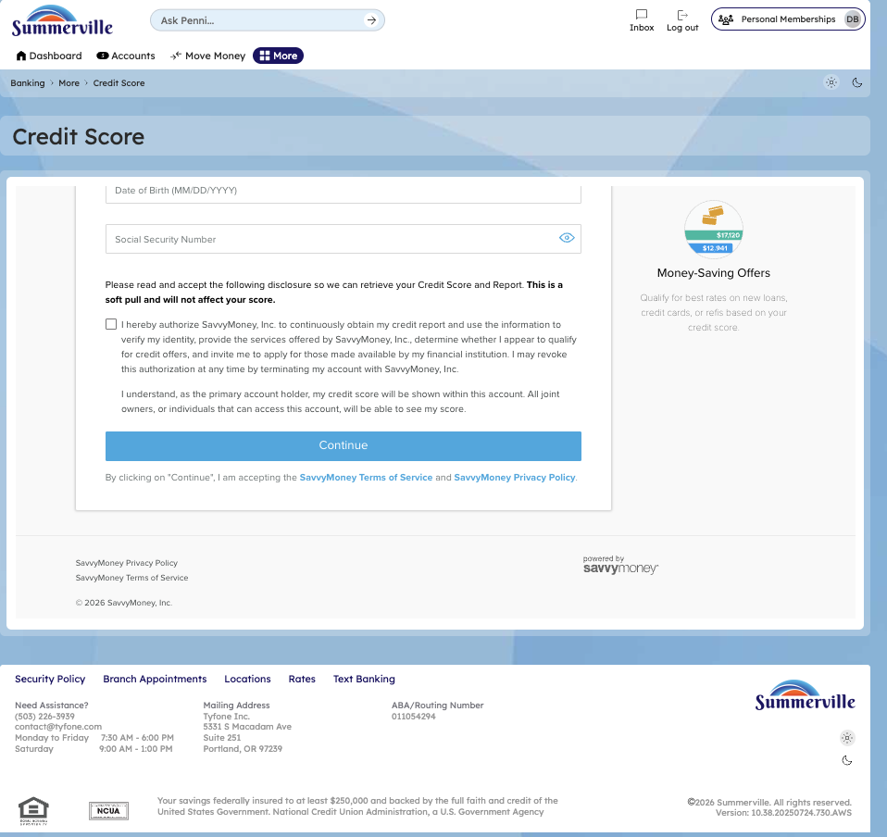
Step 5: Re-Confirm Credit Score Consent

